**Sprint 0 Document**

**Project goal:** Making a “How do you feel” application

**Secondary goals:** Developing our skills in applications

# Team

Raul Santana Trejo - Team Lead

Sjoerd Veltman - Product Owner

Serferaaz Sheikh Alibaks - Developer

Jozua Breemes - Developer

Mehran ‘You’re the Man’ Shahbackhsh – Developer

Mark Bijl - Developer

# Scope

**Features:**

Online browser login for users

Online browser dashboard for students to rate their mood

Online browser dashboard for teachers to check on their students

Online browser dashboard for admins to add and manage accounts

Online browser

Schedule an appointment with coach or the healthcare coordinator

An automated e-mail reminder for students

Different kind of accounts with own permissions (admin, teacher, student)

Online environment where question will be asked to see how you are doing.

The teachers will see whoever filled the application in and the students will be questioned.

Browser version. ( If we have time we will make it in an Android version)

Login page with the name, email.

The login page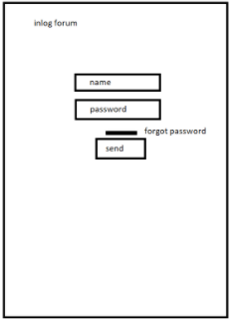

There will be a title saying: Welcome to BitAcademy.

There will be a logo in one of the corners.

We have a bar where you can put your email (name) in it.

We will have a bar for your password.

Another button for if you forgot your password.

The last button will be a send button to send the data which leads us to the next page.

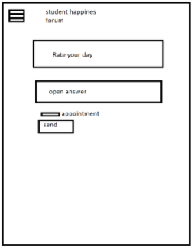

The student happiness page.

We will have a hamburger icon for more options.

Then we have text asking: How are you doing?

We will have a bar where you have 3 options ( Good, somewhat okay, bad).

Then we have another bar where you can put an open answer in. You have to be more specific about why it isn’t going well or why it is going bad. In short we need your reasoning.

We have an appointment bar to make an appointment if they feel like they need to talk. If they fill that in and click the send button, an email will be sent to the teachers.

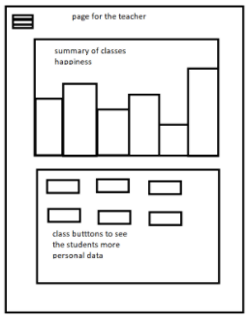

This page will only be for the teachers.

It will be a page with graphs in it. About the classes with the students of that class and their happiness levels.

There are more buttons for each class, with the students in it. If you click a button of a class you will go to another page with the students' more personal data.

There will be a hamburger icon for more options.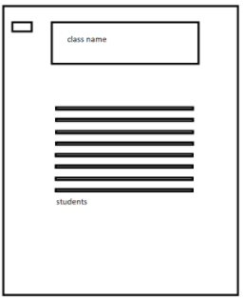

Next to it you will see the class you clicked and the name of that class.

There you will find all the personal information about the students.

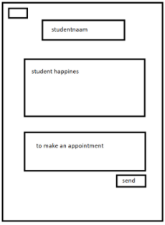

In the left upper corner we will have another hamburger icon for more options.

Then we will get to see what student we are talking about, so what the name is of the student.

Then we will have the results of the student happiness page shown.

The student will also be shown what date they planned an appointment. And it will also go to their email.

**Will do (these will definitely be in the final product)** 

Online environment where question will be asked to see how you are doing.

What we can do (for you)

If you want to talk.

runs on most browsers.

Will get notified by email

Intern software development training

Teacher can test it with their emails

**Wont do (these are officially out of scope for the project)**

An advanced styled page for the information, a bit more plain to see how and what.

Uploading pictures of the students

**Might do (these we will add if we have time, they are prioritised)**

Plan a meeting.

Add an option why it isn’t going well ( a bit more indept)

# Milestones

The first week we want to point out of who will be doing the front- or back-end. Also we want to deepen ourselves into the languages we will use for this project. We want to have a design of how it will look. Also we will work on the application front- end.

Next we want to review it and focus/work on the front and back- end. We want to see what our problems are and what our solutions can be. We need to combine the front- end with the back-end.

After that we need to test the results and implement other things if we have another time.

# Communication

Our team has 2 meetings per sprint (planning and review)

Sjoerd joins: review (1hr), standup 15 mins), team lead update 10 mins)

We will talk on discord.